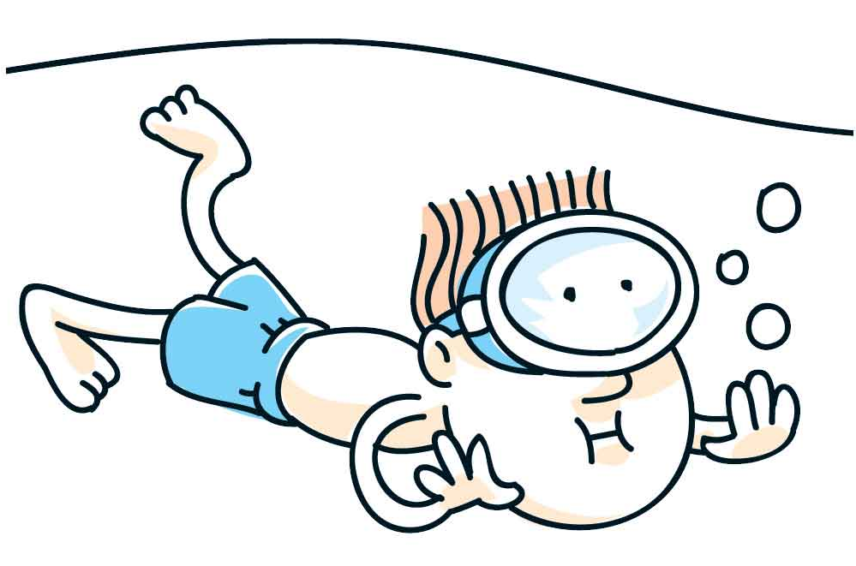
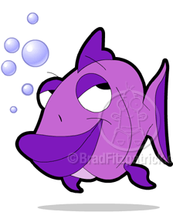
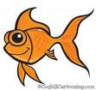
Early Childhood Swim Teachers Qualification
Songs and Nursery Rhymes

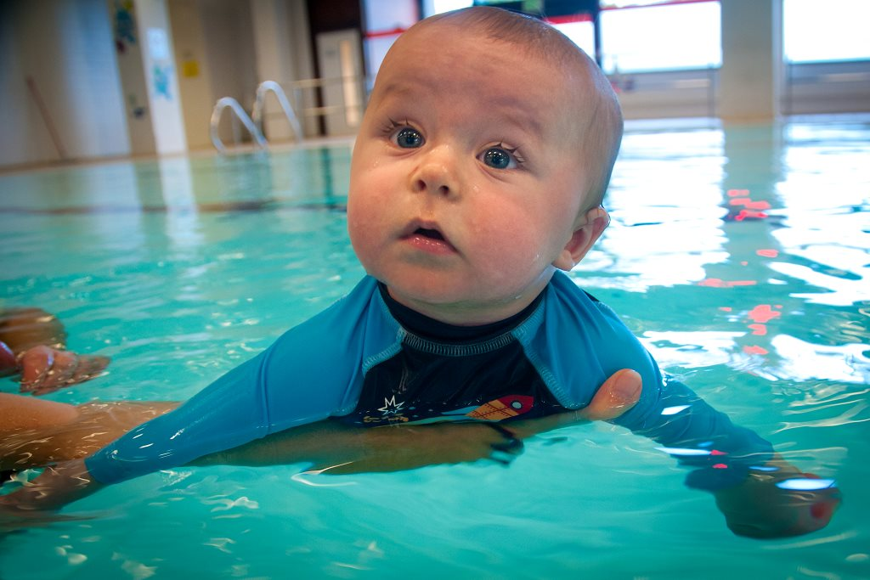

Please note: each of the following songs/rhymes helps meet a specific obejective through structured play. These can be adapted for use throughout the Early Years programme.
Movement: The Key to Learning
Children are born to move
Songs can be used in lessons for children of all levels and stages of development. It is important to understand that practice and progressions are essential if you are to acheive the objectives.
These songs can be used with or without adult support and can be organised in the following ways:
- In circles moving or stationary
- In a line travelling across the pool (waves/staggers)
- Random moving or stationary across the pool
- In small groups
- With partners

A variety of holds can be used in accordance with the child’s age and stage of development.
Learning the songs or rhymes verse by verse, along with the use of repetition, will allow the child to become more familiar with the words and actions.

Welcome Song
Chris is here today
Chris is here today
Let’s all make a splash ‘cause Chris is here today

Pancake Song (I’m a Little Tea Pot)
I’m a little pancake on my back
I’m a little pancake nice and flat
I’m a little pancake on my back
Just tip me over and swim me back

I’m a little pancake on my tum
I’m a little pancake having fun
I’m a little pancake on my tum
Roll me over to see the sun

Tick Tock
Tick tock tick tock I’m a little cuckoo clock
Tick tock tick tock now I’m striking one o’clock (2 o’clock then 3 o’clock)
(Gently rock child from side to side and push up on strikes, face parent to start with, then face rest of class when confident)

Wheels on the Bus
The wheels on the bus go round and round
Round and round
Round and round
The wheels on the bus go round and round
All day long
...wipers go swish
...horn goes beep
...motor goes brm
...children go splash
...feet go kick
Green Frog
Splash splash went the little green frog one day
Splash splash went the little green frog
Splash splash went the little green frog one day
And we all go splash splash splash

Horsey Horsey
Horsey horsey don’t you stop
Let your feet go clippety clop
The wheels go around
And the horse says Nay
Giddy up we’re homeward bound

Entry game
As tall as a house
As small as a mouse
As fat as a cat
As thin as a pin
We all float in

Row your boat
(Baby in prone hold)
Row Row Row your boat
Gently down the stream
If you see a crocodile
Don’t forget to scream

(Baby in cradle hold)
Row Row Row your boat
Gently down the stream
If you see a crocodile
Don’t forget to scream
Row Your Boat (Version 2)
Row row row your boat gently down the stream
Merrily merrily merrily merrily life is but a dream
Row row row your boat gently down the stream
Whoops I tricked you it’s a submarine

If you’re happy and you know
If you’re happy and you know it clap your hands
If you’re happy and you know it clap your hands
If you’re happy and you know it then you really ought to show it
If you’re happy and you know it clap your hands
...blow bubbles
...make a splash
...wave goodbye
...kick your feet
...splish and splash
...wash your tummy

If you’re happy and you know (Version 2)
Put the water on your nose on your nose
Put the water on your nose on your nose
Put the water on your nose put the water on your nose
Put the water on your nose on your nose
…chin
…mouth
…ear
…hair

Ten Green Frogs
Ten green frogs hopping up and down
Ten green frogs hopping up and down
And if one green frog should decide to go and swim
There would be 9 green frogs hopping up and down
Aeroplane song
Head’s in the water
Nose to the sky
Sit straight up
Like there’s water in your eye
Fly around your partner, like an aeroplane
Then come into land, and do it all again

Down at the station
Down at the station early in the morning
See the little puff-a-billies all in a row
See the engine driver climb up on the engine
“Puff Puff”
“Toot Toot”
Off we go

Hokey Cokey (Whale Wiggle or Fishy Wishy)
You put your left hand in
You put your left hand out
You put your left hand in and you shake it all about
You do the fishy-wishy (wiggle) and you turn around
That’s what it’s all about
…you put your right hand in
…you blow bubbles in
…you put your whole self in

Head shoulder knees and toes knees and toes

Head shoulder knees and toes knees and toes
Head shoulder knees and toes knees and toes
Head shoulder knees and toes
And eyes and ears and mouth and nose
Head shoulders knees and toes, knees and toes.
Back Float (Tune: Twinkle twinkle little star)
Twinkle twinkle little toes
This is how my back float goes
Ears in the water
Tummy up high
Like a speed boat I float by
…like a tug boat I float by
…like a sail boat I float by
…like a star fish I float by
…like a lily pad I float by

Crabs and Sea shells (Tune: Frere Jacque)
Crabs and sea shells
Crabs and sea shells
Dolphins to
Dolphins too
Octopus and penguins
Octopus and penguins
We swim too
We swim too

Hickory Dickory
Hickory Dickory dash
The children make a big SPLASH
They turn around
They touch the ground
Hickory Dickory Dash
Hickory Dickory dare
The children jump up in the air
Their bubbles went in
They were learning to swim
Hickory Dickory dare

SLIPPERY FISH

A Slippery Fish, a Slippery Fish swimming through the water
A Slippery Fish a Slippery Fish............
OH NO! He's been eaten by a Tuna Fish
A Tuna Fish a a Tuna Fish swimming through the water
A Tuna Fish a Tuna fish.................
OH NO! He's been eaten by an Octopus
A Octopus an a Octopus swimming through the water
An Octopus an Octopus....................
OH NO! He's been eaten by a Big White Shark
A Big White Shark, A Big White Shark swimming through the water
A Big White Shark, A Big White Shark GULP GULP GULP!!!!!

Gallop went the little green frog
Gallop went the little green frog one day
Gallop went the little green frog
Gallop went the little green frog one day and the frog went Gallop gallop gallop
But we all know frogs go (pause) Ladidadida (pause) ladidadida (pause) ladidadida
But we all know frogs go (pause) Ladidadida they don’t go Gallop gallop
Splish splash went the little green frog one day …
Kick kick went the little green frog one day …

5 Little ducks went out to play
5 Little ducks went out to play
Over the pond and far away
Mummy duck said Quack, quack, quack…
4 little ducks came back
(Repeat with 4, 3, 2 and 1)

Teddy Bear Teddy Bear
(Action: Copy teddy bears)
Teddy Bear Teddy Bear up and down
Teddy Bear Teddy Bear turn around
Teddy Bear Teddy Bear touch your toes
Teddy Bear Teddy Bear touch your nose
Teddy Bear Teddy Bear to and fro
Teddy Bear Teddy Bear lots of bubbles we blow

Teddy Bear Teddy Bear touch your toes
Teddy Bear Teddy Bear wet your nose
Teddy Bear Teddy Bear to and fro
Teddy Bear Teddy Bear down we go

5 green and speckled frogs
5 green and speckled frogs
Sat on a specked log
Eating some most delicious bugs
Yum, Yum
One jumped into the pool
Where it was nice and cool
Now there were four green specked frogs

Number songs
One, two, three, four, five
Once I caught a fish alive
Six, seven, eight, nine, ten,
Then I let it go again
Why did you let it go?
Because it bit my finger so
Which finger did it bite?
This little finger on my right
Motor Boat Motor Boat
Motor boat motor boat go so fast
Motor boat motor boats go so slow
Motor boat motor boat step on the gas

Names in the group or family…
Wish wash Jessica wish wash (swoosh the water sideways twice like wind screen wipers)
Wish wash Jessica wish wash
Splish splash Kody Splish splash (splash on the water twice with your hands)
Splish splash Kody splish splash
Bibble bubble Lucy bibble bubble (blow bubbles twice)
Bibble bubble Lucy bibble bubble
Clap hands Nicholas clap hands …

The children in the pool (Tune: Wheels on the Bus)
The children in the pool jump up and down
Up and down
Up and down
The children in the pool
Jump up and down all day long

Tony Chestnut

Toe, knee, chest, nut, nose
I love you
Toe, knee, nose
Toe, knee, nose
Toe, knee, chest, nut, nose
I love you
Toe, knee, nose
Toe, knee, nose
That’s what toe knee chest nut nose

Shake, Shake
Shake, shake, rattle, rattle
Shake, shake, rattle, rattle
Shake, shake, rattle, rattle
Roll over

Bounce, bounce
Bounce, bounce all around
Bounce, bounce, bouncing is so much fun
Bouncing around the swimming pool
...landing on your bottom
...blowing lots of bubbles

Ring a Roses (in a circle)
Ring a ring of Roses
A pocket full of poses
A tissue, a tissue, we all...
...fall down
...blow bubbles
...jump up

Like a Teddy Bear
Round and round the garden like a teddy bear,
One step, two step and jump up in the air.

Twinkle, Twinkle Traffic Light (Helen’s School of Swimming)
Twinkle, twinkle traffic light,
On the corner shining bright.
Red means stop,
Green means go,
Orange means go but very slow.
Twinkle, twinkle traffic light,
On the corner shining bright.
How much is that Fishy
How much is that fishy in the fish bowl?
The one with the wiggly tail
How much is that fishy in the fish bowl?
I do hope that fishes for sale.

How much is that fishy blowing bubbles
The one with the googly eyes
How much is that fishy blowing bubbles
I do hope that fishes for sale.

Fishes in the water
Fishes in the water, fishes in the sea
We all jump up on a 1-2-3
Fishes in the water, fishes in the sea
We all blow bubbles on a 1-2-3.

Hi Ho
Hi Ho Hi Ho It’s out the pool we go,
We take our time and out we climb,
Hi Ho Hi Ho Hi Ho Hi Ho!

There’s a Worm at the Bottom of the Garden
There’s a worm at the bottom of the garden,
And his name is Wiggle Woo.
There’s a worm at the bottom of the garden,
And all that he can do,
Is wiggle all day and wiggle all night.
There’s a worm at the bottom of the garden,
And his name is Wiggle Woo

Zoom, Zoom, Zoom
Zoom zoom zoom, we are going to the moon,
Zoom zoom zoom we are going very soon,
5, 4, 3, 2, 1 blast off!

Five Little Monkeys
Five little monkeys sitting in a tree,
Teasing mister crocodile,
You can’t catch me!
Along came Mister Crocodile as quietly as can be,
And SNAP SNAP SNAP!
Frightening the children away

Noodle Tunnel
Round and Round the swimming pool,
Like a teddy bear.
One swim two swims,
We are going under there.

Rock-a-Bye Baby
Rock-a-bye baby in your small boat.
When the wind blows, your small boat will rock.
When the wind falls, your small boat will float,
Safely to shore, baby and all.

Sleeping Bunnies
See the bunnies sleeping till it’s nearly noon,
Shall we wake them with a merry tune?
They’re so still, are they ill, wake up little bunnies!

Hop little bunnies, hop hop hop,
Hop hop hop, hop hop hop.
Hop little bunnies, hop hop hop,
Hop hop hop.
London’s Burning
London’s burning, London’s burning.
Fetch the engines, fetch the engines.
Fire, fire, fire fire!
Pour on water, pour on water.
London’s burning.

I’m a Little Teapot
I’m a little teapot,
Short and stout.
Here is my handle,
Here is my spout.
When I get all steamed up, Hear me shout,
Tip me up and pour me out!

I’m a clever teapot,
Yes, it’s true.
Here’s an example of what I can do.
I can turn my handle into a spout,
Tip me up and pour me out!

Puffer Trains
Down at the station, early in the morning,
See the little Puffer trains all in a row.
Here comes the driver to start up the engine,
PUFF PUFF, PEEP PEEP off we go!

Polly
Polly makes a splash again,
Polly makes a splash again,
Polly makes a splash again,
We all get wet.
The Grand Old Duke of York
The Grand Old Duke of York,
He had ten thousand men.
He marched them up to the top of the hill,
And he marched them down again.

And when they’re up, they’re up,
And when they’re down, they’re down
And when they are only halfway up
They’re neither up nor down.

He marched them to the left,
He marched them to the right.
He marched them around and around and around,
And he marched them out of sight.

Old MacDonald

Old MacDonald had a pond E-I-E-I-O.
And on that pond he had some ducks E-I-E-I-O.
With a splash splash here,
And a splash splash there.
Here a splash, there a splash, everywhere a splash splash.
Old MacDonald had a pond E-I-E-I-O.
…fish
…frogs
…swans

Mulberry Bush
Here we go round the swimming pool,
The swimming pool, the swimming pool.
Here we go round the swimming pool,
On a cold and frosty morning.

This is the way…
…we splash our hands
… we kick our legs,
… we blow bubbles
… we turn around
… we jump up and down
… we wash our face

Dingle Dangle Scarecrow
When all the cows were sleeping and the sun had gone to bed
Up jumped the scarecrow and this is what he said.
I’m a dingle dangle scarecrow with a flippy floppy hat.
I can splash my hands like this and kick my legs like that.

When all the hens are roosting and the moon behind the cloud.
Up jumped the scarecrow and shouted very loud.
I’m a dingle dangle scarecrow with a flippy floppy hat.
I can splash my hands like this and kick my legs like that.

Sea
Here is the sea, the wavy sea,
Here is boat and here is me.
And all the fishes go down below,
Wiggle their tales and away they go.

Jelly on a plate
Jelly on a plate, jelly on a plate
Wibble wobble, wibble wobble, jelly off the plate
Sausage in a pan, sausage in a pan
Sizzle sizzle, sizzle sizzle, sizzle sizzle bang!
Noodles on a fork, noodles on a fork
Twirly wirly, twirly wirly, noodles on a fork
Popcorn in a pot, popcorn in a pot
Popping popping, never stopping, popcorn in a pot
Honey on a spoon, honey on a spoon
Runny honey, runny honey, honey on a spoon
Jelly on a plate, jelly on a plate
Wibble wobble, wibble wobble, jelly on a plate

Two Little Ducks
Two little ducks that I once knew,
Fat ducks, skinny ducks, there were two.
But the one little duck with feathers on his back,
He led the others with a quack, quack, quack.

Banbury Cross
Ride a cockhorse to Banbury Cross,
To see a fine lady upon a white horse,
Rings on her fingers and bells on her toes,
She shall have music wherever she goes.
Pop goes the Weasel
'Round and 'round the cobbler's bench
The monkey chased the weasel,
The monkey thought 'twas all in fun
Pop! Goes the weasel.
A penny for a spool of thread
A penny for a needle,
That's the way the money goes,
Pop! Goes the weasel.
A half a pound of tupenny rice,
A half a pound of treacle.
Mix it up and make it nice,
Pop! Goes the weasel.
Up and down the London road,
In and out of the Eagle,
That's the way the money goes,
Pop! Goes the weasel.
I've no time to plead and pine,
I've no time to wheedle,
Kiss me quick and then I'm gone
Pop! Goes the weasel.

Elephant
Elephant goes like this and like that,
He’s terribly big and terribly fat.
He has no fingers, he has no toes,
But goodness gracious what a nose!

Humpty Dumpty
Humpty Dumpty sat on the wall,
Humpty Dumpty had a great fall.
All the kings’ horses and all the kings’ men,
Couldn’t put Humpty together again.
Rain, Rain
Rain, rain go away, come again another day.
All the Children want to play.
Rain, rain go to Spain, never show your face again.

Tip Toes
Can you walk on your tiptoe.
As softly as a cat?
Can you stamp along the road STAMP STAMP,
Just like that?
Can you take some great big strides,
Just like a giant can?
Or walk along so slowly,
Like a very old man?

Down in the pool
Down in the big pool,
Where nobody goes
There’s a big friendly shark there
Shaking his nose
With a splish, splash, splosh,
And a splosh, splish, splash
That’s the way he shakes his nose.

Little Miss Muffet
Little Miss Muffet sat on a tuffet,
Eating her curds and whey
Along came a spider that sat down beside her
And frightened Miss Muffet away!
Rub a Dub Dub
Rub a dub dub
Three men in a tub
And how do you think they got there?
The butcher, the baker, the candlestick – maker
They all jumped out of a rotten potato!
‘Twas enough to make fish stare

Jack be Nimble
Jack be nimble, Jack be quick
Jack jumped over the candlestick
He jumped so high he reached the sky
And he didn’t come back ‘till the fourth of July.

Jack and Jill
Jack and Jill
Went up the hill
To fetch a pail of water
Jack fell down
And broke his crown
And Jill came tumbling after

Up got Jack
And home did trot
As fast as he could caper
Went to bed
And plastered his head
With vinegar and brown paper.
Raining Pouring
It’s raining, it’s pouring,
The old man is snoring,
He went to bed,
Banged his head
And couldn’t get up in the morning

See Saw
Seesaw Margery Daw
Johnny shall have a new master
He shall earn but a penny a day
Because he can’t work any faster

Fish Bubbles
I see the fish, the fish see me
Blow bubbles to the fish, they blow bubbles back to me.

Five in bed
There was 5 in the bed
And the little one said
“Roll over, roll over!”
So they all rolled over and one fell out..

…continue with 4, 3, 2…

There was 1 in the bed
And the little one said,
“Alone at last!”

Three little fish
Three little fish went swimming one day
Around the pool and far away
Mummy fish said “blow blow, blow blow”
But only two little fish came home

Two little fish went swimming one day
Around the pool and far away
Mummy fish said “blow blow, blow blow”
But only one little fish came home

One little fish went swimming one day
Around the pool and far away
Mummy fish said “blow blow, blow blow”
But no little fish came swimming home

Mummy fish began to cry
Daddy fish said “Dry your eyes,
Look over there and what do you see?
Three little fish coming home for tea!”

Incey Wincey Spider
Incey wincey spider climbing up the spout
Down came the rain and washed the spider out,
Out came the sunshine and dried up all the rain,
And Incey Wincey Spider climbed up the spout again.

I Hear Thunder
I hear thunder, I hear thunder
Hark don’t you? Hark don’t you?
Pitter, patter raindrops
Pitter, patter raindrops,
I’m wet through; so are you.

I hear thunder, I hear thunder
Hear it roar! Hear it roar!
Pitter, patter raindrops
Pitter, patter raindrops,
I’m all wet! I’m all wet!

I see blue skies, I see blue skies,
Way up high, way up high!
Hurry up the sunshine,
Hurry up the sunshine
We’ll soon dry! We’ll soon dry!

Jack in the box
Jack in the box jumps UP like this.
He makes me laugh when he waggles his head
I gently press him down again
But Jack in the box jumps up instead.

Jumping Beans
One, two, three, four
Beans came jumping through the door
Five, six, seven, eight
Jumping up onto my plate

Swimming’s Finished
Swimming’s finished
Swimming’s finished
Time to stop
Time to stop
Swimming’s finished
Swimming’s finished
Time to stop
Time to stop

Hold Hands and Make a Ring (Tune: Brown Girl in the Ring)
Hold hands and make a ring
Tra, la, la, la, la
Kicking legs is our thing
Tra, la, la, la, la, la
Make a splash as we sing
Tra, la, la, la, la, la
Who’s next to kick round the ring

My Bonnie Lies Over the Ocean
My Bonnie lies over the ocean
My Bonnie lies over the sea
My Bonnie lies over the ocean
O bring back my Bonnie to me.

Bring back, bring back, O bring back my
Bonnie to me, to me
Bring back, bring back, O bring back my
Bonnie to me, to me

O blow ye winds over the ocean
O blow ye winds over the sea
O blow ye winds over the ocean
And bring back my Bonnie to me

Bring back, bring back, O bring back my
Bonnie to me, to me
Bring back, bring back, O bring back my
Bonnie to me, to me

The winds have blown over the ocean
The winds have blown over the sea
The winds have blown over the ocean
And brought back my Bonnie to me

Time to go home (Tune: Andy Pandy)
Time to go home, time to go home
Swimming is finished it’s time to go home
Time to go home, time to go home
See you next week, goodbye, goodbye

Kick Kick Kicking (Tune: Chick Chick a Chick Chick Chicken)
Kick kick kick kick kicking
Splash you’re little legs for me
Come on now kick kick kick kick kicking
From now until half past three
Kick keep on right on kicking, and now we need a mop
Kick kick kick kick kicking and now it’s time to stop!

Hello, How Are You? (Tune: Skip t’ m’ Lou)
Hello …………, how are you?
Hello …………, how are you?
Hello …………, how are you?
How are you today

I Can Jump In (Tune: Frere Jacques)
I can jump in, I can jump in
So can you, so can you
I can make a big splash, I can make a big splash
I’m wet through, so are you!

Row, row, row your boat
Row, row, row your boat
Gently down the stream
Merrily, merrily, merrily, merrily,
Life is but a dream

Row, row, row your boat
Gently up the creek
If you see a little mouse
Don’t forget to squeak!

Row, row, row your boat
Gently down the stream
If you see a crocodile
Don’t forget to scream!

Row, row, row your boat
Gently to the shore,
If you see a lion,
Don’t forget to roar!

Aeroplanes, Aeroplanes All in a Row
Aeroplane, aeroplanes all in a row
Aeroplane, aeroplanes ready to go,
Hark they are beginning to buzz and to Hum
Engines are working so come along come
Now we are flying up into the sky
Faster and faster oh ever so high

One Finger One Thumb Keep Moving
One finger one thumb keep moving (repeat 3 times)
We’ll all be merry and bright

One finger one thumb one arm one leg keep moving (repeat 3 times)
We’ll all be merry and bright

One finger one thumb one arm one leg nod of the head keep moving (repeat 3 times)
We’ll all be merry and bright

One finger one thumb one arm one leg nod of the head jump up jump down keep moving (repeat 3 times)
We’ll all be merry and bright

One finger one thumb one arm one leg nod of the head jump up jump down turn around keep moving (repeat 3 times)
We’ll all be merry and bright

Jumping In Song
There was ………… sitting on a rock,
Along came a wave and ………… went plop!

See The Rain Fall From the Sky (London Bridge is Falling Down)
See the rain from fall the sky
From the sky, from the sky
See the rain from fall the sky
Over “Child’s Name”

Fill the Can Up (Tune: Frere Jacques)
Fill the can up, fill the can up
To the top, to the top
Splash it on your head now, splash it on your head now,
Every drop, every drop

See My Feet Kick Up and Down (London Bridge is Falling Down)
See my feet kick up and down
Up and down, up and down
See my feet kick up and down
See me splashing

See my hands go up and down
Up and down, up and down
See my hands go up and down
See me splashing

See my jumping up and down
Up and down, up and down
See my jumping up and down
See me splashing

See the bubbles from my mouth
From my mouth, from my mouth
See the bubbles from my mouth
In the water

My Legs are Long and Straight (Tune: Knees up Mother Brown)
My legs are long and straight
My legs are long and straight
Long and straight, long and straight
My legs are long and straight

My legs kick up and down
My legs kick up and down
Up and down, up and down
My legs kick up and down

My legs go splash splash splash
My legs go splash splash splash
Splash splash splash, splash splash splash
My legs go splash splash splash

Minnie Mouse
Minnie Mouse, Minnie Mouse touch your toes
Minnie Mouse, Minnie Mouse touch your nose
Minnie Mouse, Minnie Mouse stretch up high
Minnie Mouse, Minnie Mouse now let’s fly

The Big Red Bus
A big red bus, a big red bus
A tiny little Mini and a big red bus
A big red bus, a big red bus
A tiny little Mini and a big red bus
Ferrari, Ferrari
A tiny little Mini and a big red bus
Ferrari, Ferrari
A tiny little Mini and a big red bus

A jumbo jet, a jumbo jet
A little helicopter and a jumbo jet
A jumbo jet, a jumbo jet
A little helicopter and a jumbo jet
A rocket, a rocket
A little helicopter and a jumbo jet
A rocket, a rocket
A little helicopter and a jumbo jet

